977-401 Digital Engineering Project II
Semester 1/2026

Augmented Intelligent using Image Processing and LLM: A Case Study of Patient Triage System
Project Report

Phokin Wanna 6630613024

Advisor: Aj.Wisarut Chantara

__________________________

Asst.Prof. Dr.Komsan Kanjanasit
Asst.Prof. Kullawat Chaowanawatee

College of Computing
Prince of Songkla University, Phuket Campus
Project Title Augmented Intelligent using Image Processing
and LLM: A Case Study of Patient Triage System

Author Phokin Wanna 6630613024
Major Digital Engineering
Academic Year 2026

Abstract
This project was the development of a contactless patient triage Assistant, which utilizes multiple algorithms combined with image processing. For this system is designed for helping to reduce overcrowding in the emergency department and triage area or Outpatient Department.
The system consists of three main modules:
- Vision Module that using Image Processing, algorithms and Neural Networks, specifically Convolutional Neural Networks (CNNs). To detect or classify pain gestures and physically anomaly.
- Audio Module to transcribe Thai and English spoken symptoms into text via STT (Speech-to-Text) and TTS (Text-to-Speech) models.
- Processing Module to deploy a local large language model to combine a visual and an auditory data for decision making and sent out the feedback.
The expected result of this project was a real time kiosk system. That it can classify patients into ESI levels, detect important physical signs and assist nurses by generating clinical summaries and visual evidence to reducing workload of nurses.
Keywords: Patient triage, Image processing, large language models and Emergency severity index

Acknowledgements
In this project has been completed successfully and mostly would like to thank adviser, Aj.Wisarut Chantara. For his helping direction support during the research and development process.
I would also like to thank my peers in the nursing faculty for providing necessary requirements and insights of the medical triage workflow.

Phokin Wanna
28 September 2026
TABLE OF CONTENTS

Abstract ii
Acknowledgements iii
List of Figures vi
List of Tables vii
List of Abbreviations viii
Chapter 1 Introduction 10
  - Overview 10
  - Objectives 10
  - Scope 11
  - Procedures 11
  - Expected Project Results 12
  - Locations 13
  - Development Tools 13
Chapter 2 Theory Background / Literature Review 14
  - Large Language Models (LLM) & Edge Quantization 14
  - Medical Triage Standards 15
  - Computer Vision and Pose Estimation 18
    - OpenCV 18
    - MediaPipe Framework and Pose Topology 18
  - Image Preprocessing and Skin Color Analysis 19
    - Image Resizing and Pixel Normalization 19
    - Color Space Conversion (RGB to HSV) 19
    - Histogram Analysis and Otsu's Thresholding 20
  - Automatic Speech Recognition (ASR) 21
  - Related Research 21
Chapter 3 Proposed Solution 23
TABLE OF CONTENTS (CONT.)

  - System Architecture 23
    - Input Module 23
    - Processing Module 23
    - Output Module 24
    - Speech-to-Text (STT) Constraints and Privacy Management 24
  - All System Architecture 25
  - System Design 27
    - User Interaction 27
    - Frontend and Backend Architecture 28
    - Core Processing and Logic 30
  - Project Plan 36
Chapter 4 Results and Conclusion 37

  - System Performance and Experimental Setup 37
    - Hardware Environment 37
    - Physical Environment Setup 37
    - Testing Methodology 39
  - Vision Classification Results 40
    - Gesture Detection and Dynamic Boundary Results 40
    - Skin Color Analysis 45
  - LLM Model ESI Classification Results 48
  - Latency and Computational Performance 51
    - Latency Identification 51
    - Optimization Methodologies 52
    - Post-Optimization Performance Results 52
  - Conclusion 53
  - Future Work 53
References 54

LIST OF FIGURES

Figure 2-1 General Model of LLMs 13
Figure 2-2 LLM Architected 14
Figure 2-3 ESI Triage Algorithm v4 15
Figure 2-4 OpenCV 16
Figure 2-5 MediaPipe 16
Figure 3-1 System Architecture 23
Figure 3-2 All System Architecture 25
Figure 3-3 Patient and Nurse Interface System 28
Figure 3-4 Client-Server Architecture 30
Figure 3-5 Chest Pain Recognition Logic 32
Figure 3-6 Flowchart of Skin Color Analysis using HSV 35
Figure 4-1 Hardware Specifications and Requirements 37
Figure 4-2 Distance from equipment to ground 38
Figure 4-3 Distance from equipment camera to base 39
Figure 4-4 Gesture detection’s logic 40
Figure 4-5 Testing Vision System: Normal posture 41
Figure 4-6 Testing Vision System: Chest pain posture 41
Figure 4-7 Testing Vision System: Head pain posture 42
Figure 4-8 Testing Vision System: Abdomen pain posture 42
Figure 4-9 Testing Vision System: Unnecessary posture - Scratching 43
Figure 4-10 Testing Vision System: Unnecessary posture – Crossed Arms 43
Figure 4-11 Testing Vision System: Unnecessary posture – Thinking (1) 44
Figure 4-12 Testing Vision System: Unnecessary posture – Thinking (2) 44
Figure 4-13 Image segmentation and HSV Calculated 45
Figure 4-14 Testing Vision System: Red face detected 46
Figure 4-15 Testing Vision System: Pale face detected 46
Figure 4-16 Testing skin analysis algorithm with HSV (1) 47
LIST OF FIGURES (CONT.)

Figure 4-17 Testing skin analysis algorithm with HSV (2) 47
Figure 4-18 Testing overall System: Critical emergency (scenario 1) 48
Figure 4-19 Log of scenario 1’s result 49
Figure 4-20 Testing overall System: Urgent Condition (scenario 2) 49
Figure 4-21 Log of scenario 2’s result 50
Figure 4-22 Testing overall System: Non-Urgent (scenario 3) 50
Figure 4-23 Log of scenario 3’s result 51
Figure 4-24 Latency Comparison of 16-bit and 4-bit Model 52
Figure 4-25 Log Optimized Execution Time (16-bit Model) 52
Figure 4-26 Log Optimized Execution Time (4-bit Model) 53

LIST OF TABLES
Table 3-1 Project plan 31
Table 4-1 Breakdown System Latency 48

 | LIST OF ABBREVIATIONS
ESI  gTTS | Emergency Severity Index  Google Text-to-Speech
JSON | JavaScript Object Notation
LLM  NLP | Large Language Model  Natural language processing
OPD | Outpatient Department
PDPA | Personal Data Protection Act
ROI | Region of Interest
SOAP | Subjective Objective Assessment Plan
STT | Speech-to-Text
TTS | Text-to-Speech
CNN | convolutional neural network
ASR | Automatic Speech Recognition

Chapter 1 Introduction

This chapter covers the background, objectives, scope, methodologies, expected project outcomes, as well as the location and tools used for system development.

Overview
Hospital congestion is rarely caused by trauma cases alone most crowding happens right at the front lobby and Outpatient Department (OPD). Around 80 to 90% of patients are general walk-ins seeking routine care and nurses spend hours every day asking the same repetitive medical history questions. At the same time, nurses must stay on high alert because severe or time sensitive emergencies like silent heart attacks or strokes, can walk into the general waiting area unnoticed.
This project proposes a Contactless Patient Triage Assistant. Placed at hospital entrance points and screening areas. This kiosk screens patients without physical contact by combining computer vision, speech recognition and a local Large Language Model (LLM). The system adapts its interview based on urgency:
- For critical cases: If catches visual pain’s signs or skin distress before or in between conversation, skips lengthy questioning to ask only essential details and immediately alerts nurses.
- For stable cases: It conducts a routine medical history interview in Thai or English and drafts a clinical summary, taking the repetitive documentation burden off nursing staff while keeping emergency safeguards in place.

Objective
1.2.1 Detect acute pain postures (chest, head, abdomen) and to classify abnormal facial redness or flushing.
1.2.2 Deploy a local LLM to evaluate urgency using ESI standards, asking concise questions for emergencies while handling full history interviews for stable patients.
1.2.3 Assist nurses by provide a triage summaries or SOAP notes and visual evidence.

Scope

1.3.1 Target Users & Setting
- Placement: Hospital lobbies, OPD screening points, and triage waiting areas.
- Target Patients: Conscious adult walk-in or wheelchair patients standing or sitting 1.0 - 1.5 meters from the kiosk.
- Exclusions: Unconscious patients (sent straight to resuscitation), stretcher or bedridden patients, and pediatric cases.

1.3.2 Technical Scope
- Hardware: 1080p webcam, build-in microphone and an Apple M1 Mac with 7 core GPU and 8GB Unified Memory.
- MediaPipe joint tracking, CNN for facial skin classification and 4-bit Llama 3.2 for clinical reasoning.
- On device execution in RAM with no cloud uploads. Provide a structured JSON payload contains automated SOAP draft and photo evidence to the nurse's screen over LAN.

Procedures
Step 1: Nurse Interviews
- Interview nursing students, to understand triage workflows.
Step 2: Vision Module Development
- Built MediaPipe geometric logic for pain poses
- Trained a custom CNN for facial redness or flushing detection.
Step 3: Audio & Logic Development
- Implement Speech Recognition for bilingual (Thai and English) speech-to-text processing.
- Fixing the Llama 3.2’s parameter.
- Integrate TTS (Text-to-Speech) for automated bilingual voice response generation.
Step 4: System Optimization
- Rebuilt the backend into a 4-core parallel architecture and quantized the LLM to 4-bit.
Step 5: Testing & Evaluation
- Tested the kiosk using simulated patient cases ranging from critical conditions to mild illnesses.
- Then evaluate classification accuracy and response time process.
Step 6: Deployment
- Built a local web interface and Provide a Json file that it must contain patient info and ESI level.
Step 7: Final Documentation
- Complete the report, documentation and evaluation results.

Expected Project Results
- Identify ESI levels and detects physical distress cues (posture, facial flushing).
- Cut intake time from several minutes to under 30 seconds by generating SOAP notes.
- Can handle critical emergencies while automating routine questions for stable walk-in patients.
- Provide a reliable and complete offline system environment that protects patient privacy under PDPA laws.

Locations
- College of Computing, Prince of Songkhla University, Phuket Campus.

Development Tools
Software
- Programming Language: Python 3.10+
- AI & Vision Frameworks: MediaPipe, TensorFlow & TensorFlow Lite, SpeechRecognition, Fast Whisper, gTTS, Ollama (Llama 3.2)
- Interface: Streamlit / HTML, CSS, JavaScript
Hardware
- Apple M1 Mac (8-core CPU, 7-core GPU, 8GB Unified Memory).
- Built-in 1080p webcam and microphone.

Chapter 2 Theory Background/Literature Review

An overview of the fundamental theoretical and principles that used as the foundation for this project.

Large Language Models (LLM) & Edge Quantization

2.1.1 Transformer Architecture & Contextual Understanding
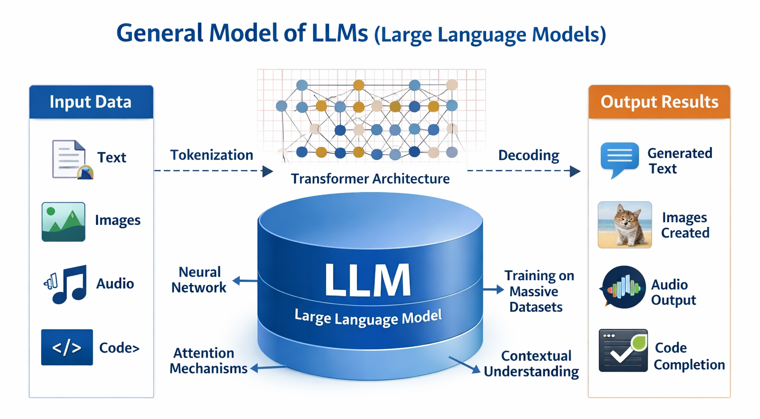

Figure 2-1 General Model of LLMs
A large language model (LLM) [1] is an artificial intelligence (AI) system that designed to understand and generate human language. Unlike older rule-based natural language processing (NLP) models that search for rigid keywords, modern LLMs are built on the Transformer architecture.
It was the Mechanism within the transformer architecture [2]. This mechanism allows the model to weigh the relevance of different words in a sentence simultaneously, rather than processing them sequentially. The input text will break down into numerical pieces that were "tokens” which calculates mathematical relationships between all words in a sentence simultaneously. And The model then applies to understand the semantic relationships between these tokens. Incorporate techniques Grouped Query Attention (GQA) and parameter quantization.

2.1.2 4-Bit Parameter Quantization
Deploying an LLM directly on edge hardware, such as an Apple M1 Mac with 8GB of Unified Memory that is creates a major memory bottleneck. In standard 16-bit floating-point format, models like Llama 3.2 require roughly 5.5 to 6.0 GB of memory. In an 8GB system, this leaves almost no memory for the operating system, camera feeds, MediaPipe or CNN inference that leading to memory swapping and unacceptably high latency (~27.2 seconds per response).
To make edge execution viable, the system applies 4-bit post-training quantization using the local Ollama runtime, drawing on quantization principles [3] established:
- Quantization compresses the model’s weight representations from 16 bits down to 4 bits.
- This reduces the active model footprint from ~6 GB down to ~2 GB, preserving over 70% of memory for the vision and audio threads.
- Running across the Apple M1's unified high-bandwidth memory, token generation speed improves dramatically, reducing total inference time from 27.2 seconds down to 5.8 seconds without degrading conversational triage reasoning.

2.1.3 Prompt Engineering & Output Schema Constraining
In a medical setting, generative language models must not produce verbose conversational text or hallucinate unverified medical conditions.
To ensure deterministic, clinically reliable behavior. This project uses structured prompt constraints:
- The system prompt restricts the model to a pre-triage assistant tasked solely with assessing urgency via the Emergency Severity Index (ESI Version 4). Definitive medical diagnosis is explicitly barred.
- Visual pain flags and transcribed speech are formatted as key-value pairs before entering the prompt.
- The model is constrained to return only a valid JSON payload containing specific keys contain ESI level, Clinical summary, Action needed, and SOAP note. This guarantees the output can be parsed programmatically and rendered instantly onto the Nurse Dashboard.

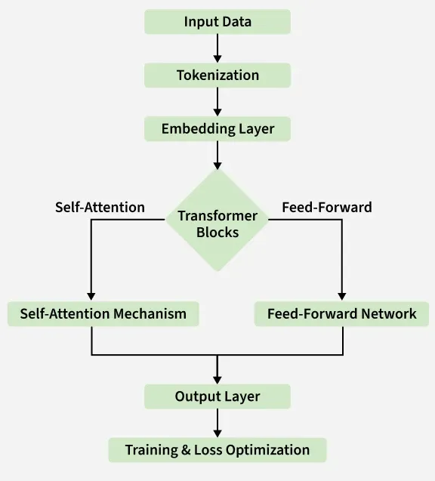

Figure 2-2 LLM Architecher

Emergency Severity Index (ESI) Triage Standard [4]
This project references the Emergency Severity Index (ESI) Version 4, developed by the Agency for Healthcare Research and Quality (AHRQ) in USA. This standard provide as the Core Logic for the Large Language Model to evaluate patient urgency and categorizing them into five levels as follows:
- Level 1 (Resuscitation)
  - Definition: A patient with a life threatening condition, that needs help right away. Without immediate medical treatment, the patient is at high risk of dying.
  - Symptom: Unconscious, have stopped breathing or are gasping for air or are experiencing heart failure or severe shock.
- Level 2 (Emergent)
  - Definition: Is in a high risk situation, experiencing severe pain (between 7 - 10), or showing with acute confusion. Treatment must be start within 10 - 15 minutes.
  - Symptom: Severe chest pain, unilateral weakness, suspected stroke or severe dyspnea.
- Level 3 (Urgent)
  - Definition: Has stable vital signs but requires "two or more evidence" for evaluation and treatment. Treatment should begin within 30-60 minutes.
  - Symptom: Severe abdominal pain and closed fractures requiring X-rays and splinting or high fever with dyspnea, etc.
- Level 4 (Less Urgent)
  - Definition: Has stable vital signs and is expected to require "only one evidence" for evaluation and treatment.
  - Symptom: Minor lacerations, sprained ankle, or suspected urinary tract infection (UTI).
- Level 5 (non urgent)
  - Definition: General patients seeking treatment for minor illnesses. Require no resources beyond a standard physical examination and a medical prescription.
  - Symptom: Common cold, sore throat, minor rashes, prescription refills or routine wound dressing.

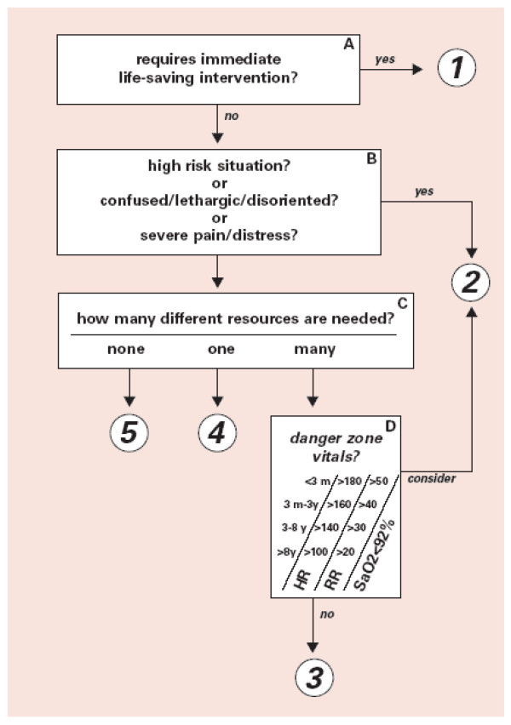

Figure 2-3 ESI Triage Algorithm v4 [3]

Computer Vision & Pose Topology
Computer vision is a subfield of artificial intelligence that enables computers to derive high-level understanding from digital images or videos.

2.3.1 OpenCV [5]
OpenCV is a highly optimized open source programming library designed specifically for real time computer vision and machine learning applications.
- OpenCV processes images as multi-dimensional matrices. It applies linear algebra and matrix operations to alter these pixels. For instance, it can convert a standard RGB matrix into a different color space such as HSV or apply a mathematical threshold to isolate specific regions of an image for further analysis.


Figure 2-4 OpenCV

2.3.2 MediaPipe Framework and Pose Topology
MediaPipe is an open-source framework developed by Google for building cross-platform, customizable machine learning pipelines for time-series data, such as video streams.
- MediaPipe Pose utilizes a machine learning architecture called BlazePose. The pipeline first uses a detector to locate the human region within the frame, and then a subsequent landmark model predicts the exact (x, y, z) coordinates of the 33 anatomical joints. These spatial coordinates can then be used to calculate anatomical angles and distances using standard Euclidean geometry and trigonometry, allowing for precise human action and gesture recognition.


Figure 2-5 MediaPipe

Deep Learning for Facial Distress Analysis
Physiological vision analysis is the process of using optical camera sensors to detect subtle changes in human skin color and perfusion that correlate with cardiovascular and autonomic nervous system responses. In medical triage, changes in facial perfusion specifically pallor (paleness from circulatory shock) or flushing (redness from high fever or hypertensive crisis) must provide vital diagnostic evidence of acute patient distress.

2.4.1 Limitations of Manual Color Thresholding (HSV)
The HSV (Hue, Saturation, Value) color space is a cylindrical color representation that models color in terms of its dominant wavelength (Hue), purity (Saturation), and brightness (Value). Traditional image processing often uses HSV to isolate color shades from illumination changes.
In initial system testing, manual HSV thresholding achieved only 56% accuracy. In real hospital lobbies, fluctuating ambient fluorescent lighting, shadows, and screen backlights from the kiosk monitor directly reflect off the patient’s face. Because Hue and Saturation are mathematically coupled to maximum and minimum RGB channel values, external screen glare distorts the calculated saturation, causing false-positive pallor detections on healthy patients.

2.4.2 Convolutional Neural Networks (CNNs) [6]
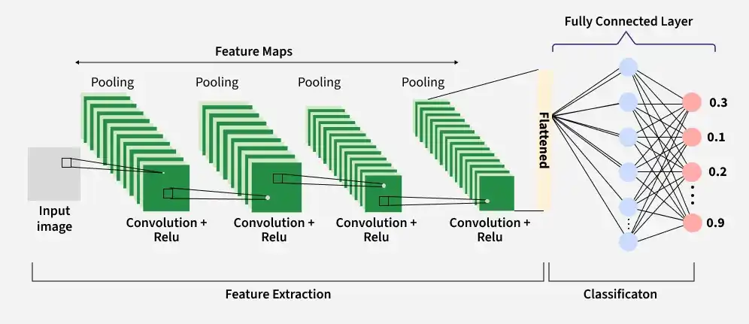
Convolutional Neural Networks are very similar to ordinary Neural Networks from the previous chapter: they are made up of neurons that have learnable weights and biases. Each neuron receives some inputs, performs a dot product and optionally follows it with a non-linearity. The whole network still expresses a single differentiable score function: from the raw image pixels on one end to class scores at the other. And they still have a loss function (e.g. SVM/Softmax) on the last (fully-connected) layer and all the tips/tricks we developed for learning regular Neural Networks still apply. Unlike traditional fully connected networks that flatten images into 1D vectors and lose spatial structure, CNNs preserve spatial relationships between adjacent pixels.
Figure 2-6 convolutional neural network concept
A standard CNNs architecture consists of three primary functional layers:
- Convolutional Layer: The fundamental building block that slides small parameter matrices (kernels or filters, such as 3 x 3) across the input image. By computing dot products between the kernel and localized receptive fields, the layer generates Feature Maps that detect low-level edges, textures, and localized color gradients.
- Activation Function (ReLU): Introduces non-linearity into the network using the Rectified Linear Unit
$ReLU (x) = max(0, x)$ (2-1)
allowing the network to learn complex non-linear clinical boundaries while preventing vanishing gradient issues during backpropagation.
- Pooling Layer: Reduces the spatial dimensions (width and height) of feature maps using operations like Max Pooling. This downsampling minimizes computational overhead, controls overfitting, and grants translation invariance (the ability to recognize a pattern regardless of its exact position in the frame).
- Fully Connected (Dense) & Output Layer: Flattens the final pooled feature maps into a vector and applies an activation function (such as Softmax for multi-class classification or Sigmoid for binary classification) to output a probability distribution across target clinical classes.

2.4.3 Edge Model Optimization with TensorFlow Lite

TensorFlow is an open-source platform developed by Google for designing, training, and deploying scalable machine learning models [7]. TensorFlow Lite (TFLite) is its specialized, lightweight execution environment tailored for executing trained models on mobile, embedded and edge computing devices.
Figure 2-5 TensorFlow Lite

2.5 Automatic Speech Recognition (ASR) [8]
Automatic Speech Recognition (ASR) is a computational technology that enables the recognition and translation of spoken language into text. Modern ASR systems, such as the Whisper model that use deep learning and Transformer architectures to process audio signals.
- An ASR system takes a raw audio waveform as its input, analyzes the acoustic and linguistic properties of the sound, and generates a corresponding written transcript

2.6 Multi-Core Concurrency & Parallel Processing [9]
Parallel processing is a computational technique where multiple tasks execute simultaneously across separate processor cores to prevent resource-heavy jobs from blocking time-critical I/O operations.

2.6.1 Process and Thread Concurrency
In modern operating systems, a thread is the smallest schedulable unit of CPU execution within a process. In a single-threaded program, heavy computational tasks like LLM generation cause the entire application to pause, freezing video streams and dropping audio frames. By partitioning independent tasks across separate threads, multi-core processors maintain continuous sensor polling and interface updates while background neural networks compute inference.

2.6.1 Asynchronous Producer-Consumer Architecture
The Producer-Consumer pattern is an architectural design where producer threads generate data into shared buffers and consumer threads independently process that data. In this kiosk, high-frequency sensory tasks (30 fps camera frames and 16 kHz audio) are decoupled from slower reasoning tasks using thread-safe non-blocking FIFO queues. This asynchronous execution eliminates UI freezing and delivered a 96% speedup in system responsiveness on multi-core hardware.

2.7 Related Research
2.7.1 " Designing Effective User Interface Experiences for a Self-Service Kiosk to Reduce Emergency Department Crowding " [10]
- Medical kiosks are physical station, that it deployed in hospital waiting areas. The it integrated with biometric sensors
- Systems require patients to physically interaction, with the machine to measure signs and manually input their complaints by a touchscreen
2.7.2 " Contactless Patient Care Using Hospital IoT: CCTV Camera Based Physiological Monitoring in ICU " [11]
- In computer vision have to numerous studies on non-contact patient monitoring systems, in intensive care units (ICUs) and emergency ward
- They are using RGB and thermal cameras to extract physiological signals. And detect pain levels through facial expression analysis and posture estimation algorithms
2.7.3 "Large language models in medicine." [12]
- There is a growing body of research on the application of LLMs in healthcare for clinical note generation and patient interaction
- Modern systems transcribe patient-doctor conversations and generate structured clinical summaries using powerful cloud-based APIs
- Cloud based LLMs give significant data privacy (PDPA/HIPAA) and latency challenges in emergency medical settings. by using a locally deployed. This ensures complete data privacy while simultaneously fusing auditory data with real time visual metadata to make safety critical triage decisions
The proposed Smart Contactless Patient Triage Assistant, makes the limitations of existing solutions. First, unlike traditional kiosks, it is completely contactless, reducing infection risks and physical strain on critical patients. Second, it achieves multimodal combination by cross verifying visual physiological anomalies with verbal symptoms in real time and surpassing single domain AI tools. Finally, by deploying the LLM reasoning module locally on local hardware. The system ensures strict PDPA compliance. That was eliminating the privacy risks associated with cloud based LLM.

Chapter 3 Methodology & System Architecture

This chapter presents the architectural framework, design principles, mathematical logic and implementation details of this project. Developed specifically for emergency department intake and Outpatient Department (OPD) screening points, the system executes multimodal artificial intelligence models such as CNN and LLM entirely on edge computing hardware to deliver real time triage evaluations under strict data privacy regulations.

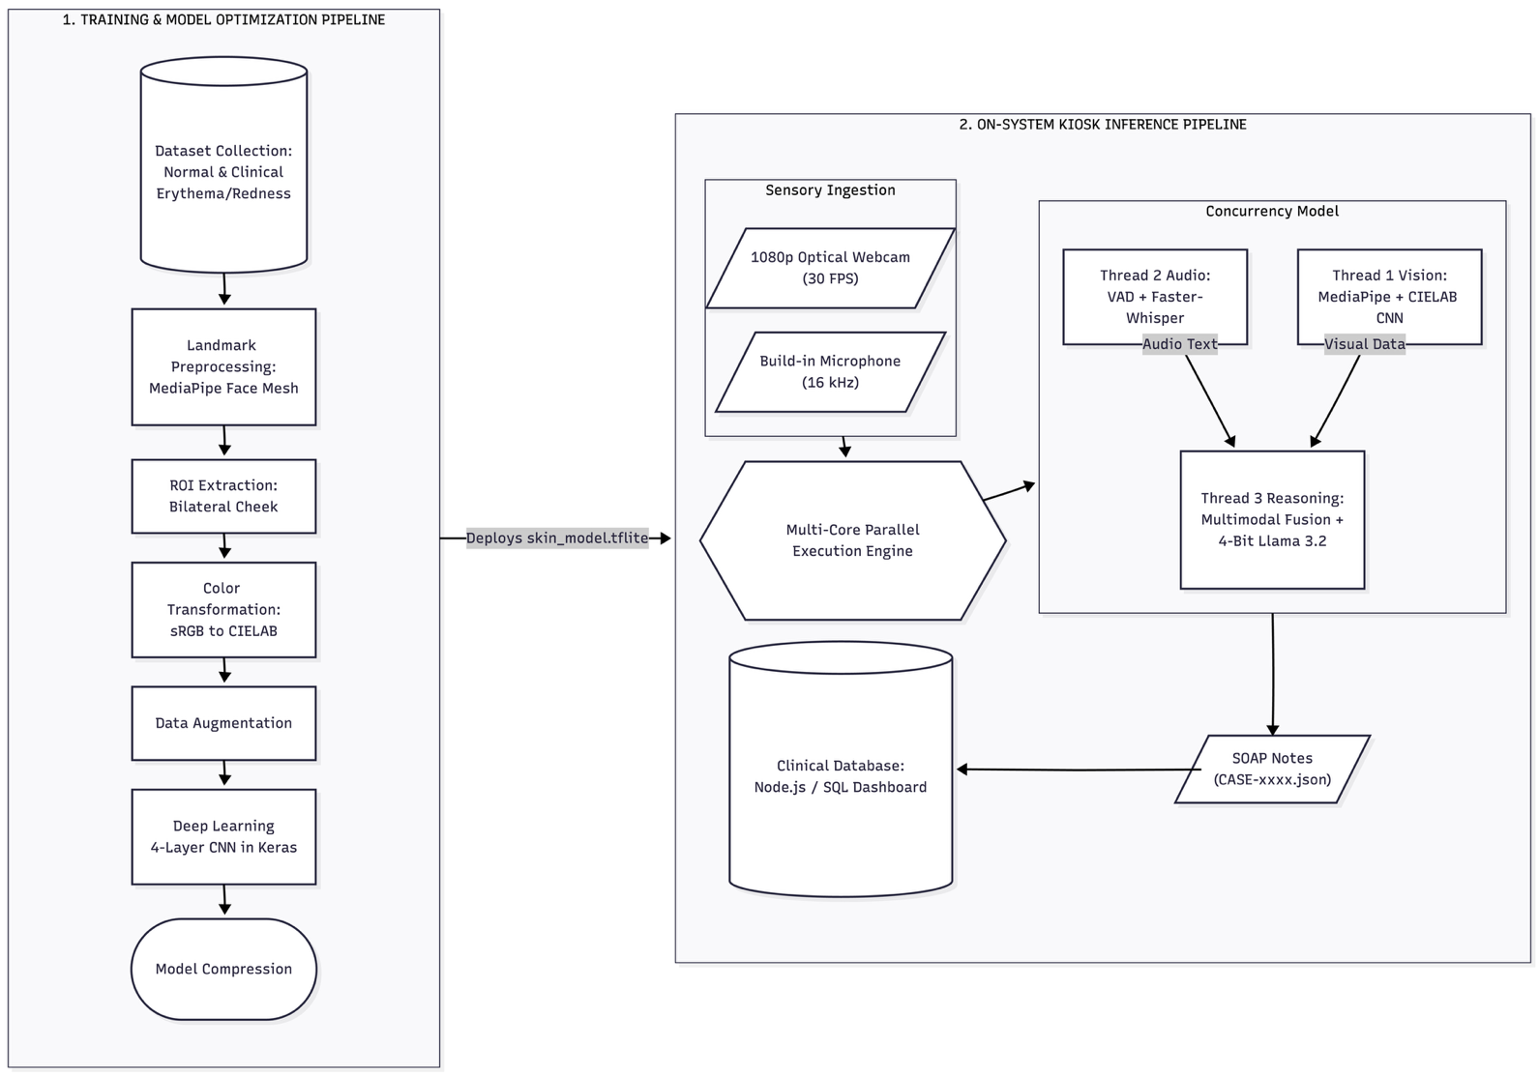
System Architectures
Figure 3-1 System Architecture
The proposed system employs an edge-native, multimodal pipeline that captures, synchronizes and evaluates visual physical indicators and conversational acoustic speech concurrently. To ensure methodological clarity and satisfy engineering standards for machine learning systems, the architecture is partitioned into two distinct operational pipelines:
- Training and Model Optimization Pipeline: Governs data collection, color space preprocessing, CNN feature learning, and edge quantization for facial distress detection.
- On-System Kiosk Inference Pipeline: Governs live sensory capture, asynchronous multithreaded processing, heuristic geometric disambiguation, LLM clinical reasoning and automated nurse station dispatch.

Offline Training and Model Optimization Pipeline

The offline pipeline trains and compresses the deep learning model that detects acute facial flushing (erythema). Facial flushing serves as a vital diagnostic cue indicating physiological distress, such as hyperthermia, high fever, or hypertensive crisis.

- Dataset Acquisition and Preparation:
- A balanced dataset of facial images was compiled, incorporating diverse skin phototypes (Fitzpatrick scales I–VI) in both normal resting states and documented clinical/simulated erythema states.
- Dataset samples were curated under varying illumination angles and background conditions to build resilience against ambient hospital lighting variations.
- Automated ROI Segmentation via Facial Landmarks:
- Rather than processing entire facial frames. Which introduce background clutter and non-skin artifacts such as hair, sclera and oral cavities. And the pipeline uses Google MediaPipe Face Mesh.
- Three facial landmark anchors are tracked per side: the inner ocular canthus, the alar base of the nose, and the auricular tragus.
- The centroid of these coordinates defines the center of a dynamic bounding box ($64×64$ pixels) that isolates the smooth malar cheek surface.

- CIELAB Color Space Transformation & Channel Extraction:
- The extracted RGB pixel matrices are mapped to the device independent CIELAB ($L^{*}a^{*}b^{*}$) color space.
- Because the $L^{*}$ component represents luminance and is mathematically decoupled from the chromatic channels, the $a^{*}$ axis (which quantifies position along the green and red continuum) directly isolates blood perfusion changes and capillary dilation.
- Contrast normalization and color jitter augmentations are applied to enhance chromatic boundaries along the $a^{*}$ dimension.

- CNN Architecture Design & Training:
- A dedicated four-layer Convolutional Neural Network (CNN) is designed to operate on the preprocessed CIELAB feature patches.
- The architecture uses alternating $3×3$ convolutional filters with Rectified Linear Unit (ReLU) activation functions, Batch Normalization and Max Pooling ($2×2$) layers to extract hierarchical chromatic and texture features.
- A Dropout layer ($p=0.3$) precedes the fully connected dense layers to prevent overfitting.
- The output layer employs a Softmax activation function to compute posterior class probabilities:
$\overset{ˆ}{y}=\text{Softmax}\left(W_{d}⋅f+b_{d}\right)$ (3-1)

classifying patches into ${\text{Class}}_{0}$ (Normal Perfusion) or ${\text{Class}}_{1}$ (Acute Flushing/Erythema).
- Model Compression via TensorFlow Lite (TFLite):
- To enable real-time inference on edge hardware without competing for memory bandwidth against the vision and LLM threads, the trained Keras model (.h5) is compiled into a TensorFlow Lite (.tflite) FlatBuffer.
- Post-training quantization optimizes weights into a compact binary file under 2.5 MB, achieving sub-10ms inference latencies on edge CPU cores.

Figure 3-1 System Architecture

Input Module
Input Module will capture patient data, instantly when their arrival at the triage area.
- Visual Input using a webcam to captures the patient, specifically focusing on their upper body posture and facial area
- Audio Input by microphone captures the Patient info and symptom descriptions in the Thai or English language

Processing Module
- Vision module analysis the video input using Media Pipe Pose to detect pain gestures and OpenCV color analysis to identify facial anomaly specifically on redness or flushing face
- Audio module that use the Whisper model for transcribe the patient spoken Thai or English symptoms into text
- Reasoning module it evaluates both the transcribed both audio and visual data to describe the urgency of the patient's condition

Output Module
- Audio Output using a Text to Speech module. Response asking the follow up questions or instructing the patient to wait. Into Thai or English speech through the kiosk's speaker to guide the patient
- Data Output for the Nurse and the reasoning module formats its will conclusions into a JSON payload that was include:
  - ESI level the predicted emergency level ranging from 1 to 5
  - Summary a context from input of the patient's symptoms
  - Visual evidence snapshot for the nurse to verify more about the case

Speech-to-Text (STT) Constraints and Privacy Management
For noise reduction, will use a directional microphone with voice activity detection. That if ambient noise is too high, STT be bypassed with relying on the vision module. And for PDPA the kiosk operates a one way. TTS provides only basic instructions without provide a sensitive information and all patient information is securely transmitted as a JSON payload.

All System Architecture
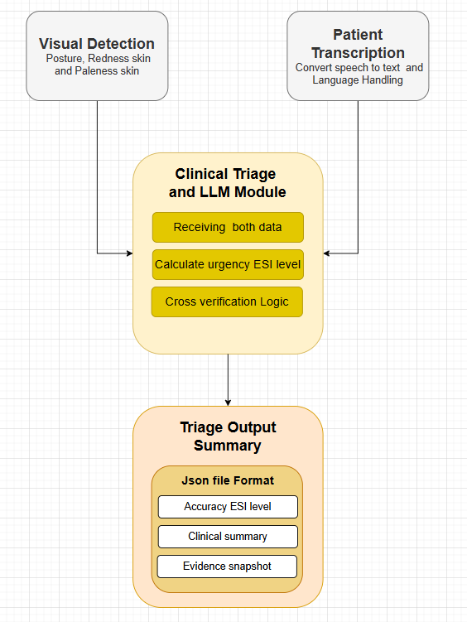
Figure 3-2 All System Architecture

- Step 1 Starting when a patient arrives at the triage area and places in front of it. Then system will require permission from user before they are using this system. Then webcam will captures the patient's physical state. While the microphone will captures their explanation of symptoms in Thai or English
- Step 2 Once the raw data is captured, it is routed to two distinct processing modules to ensure minimal latency
  - In the Vision Module the video frames are processed to extract visual metadata. MediaPipe analyzes the skeletal structure to flag any pain related postures. Then, OpenCV algorithms extract the facial region and compute color histograms in the HSV color spaces to detect physiological distress. A snapshot of the frame is temporarily saved as visual evidence
  - In the Audio Module the audio stream is sent to the Whisper model, then translates the raw Thai or English speech into a structured text
- Step 3 The extracted visual data and the transcribed text are then combined and formatted into a structured prompt. sent into the LLM. Then it will use predefined prompt instructions based on the ESI standard. It cross verifies the data to calculate the final triage severity level
- Step 4 LLM will generates the conclusion output for two users
  - System will sends a JSON file to the nurse's dashboard. That Json payload contain the calculated ESI level and a clinical summary and visual evidence snapshot containing the detected anomaly, if it was detected
  - For the patient system will convert the LLM's response into spoken Thai or English, using a TTS module. It will providing feedback or instructions to the patient through speakers

System Design

User Interaction
- As a patient, it will automatically records their verbal symptoms while observing their posture and skin color. When it processes this data, it will provide feedback or instructions to the patient through a TTS module and shows a text on the screen.
- As a nurse, system will pushes alerts to the nurse's secure web dashboard. Each case report include the calculated ESI level, a clinical summary and visual evidence snapshots. That will allows the nurse to verify the result and make the final clinical decision without leaving their station

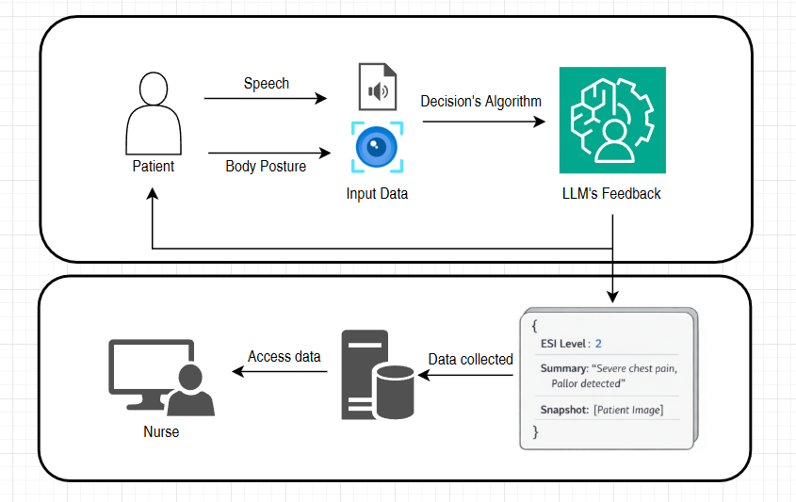

Figure 3-3 Patient and Nurse Interface System

Frontend and Backend Architecture
Frontend Architecture
- The interface acts as the data collection node. It was continuously captures a raw video streams and audio signals. It will only show the raw inputs to the backend and plays the TTS audio that was responses back to the patient.

- This interface was develop using a web framework. It functions as a monitoring dashboard that listens for incoming JSON payloads from the backend. When it receiving data, it will renders the patient's calculated ESI level and a clinical summary and a visual evidence snapshot.
Backend Architecture
- The system was a parallel processing to handle incoming streams.
- The context text base and visual flag data are sent to the LLM model. That it was running in the Ollama processor. Cause this model can processes the multiple prompt to deduce the triage level.

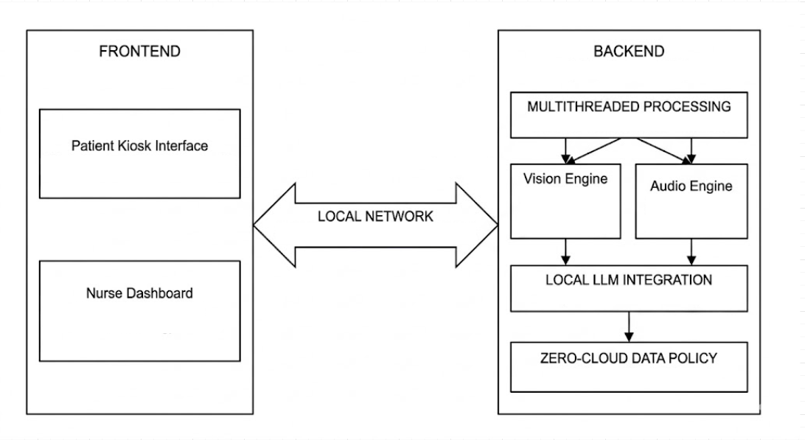

Figure 3-4 Client-Server Architecture

Core Processing and Logic
- Geometric Logic for Pose Recognition
- To define that a patient has a pain posture, system evaluates on geometric calculation by tracking on important point on body and face to check with another point on body, to define patient’s posture
- First, the system calculates the Chest Center coordinate $P_{c}$ by finding the midpoint between the Left Shoulder $P_{ls}$ and Right Shoulder $P_{rs}$
$x_{c}=\frac{x_{ls}+x_{rs}}{2}$ (3-1)
$y_{c}=\frac{y_{ls}+y_{rs}}{2}$ (3-2)
- Then use Euclidean Distance [11] (D) between the active Wrist $P_{w}$ and the Chest Center or $P_{c}$ can be calculated by Euclidean Formula
$D = \sqrt{({x_{w}-x_{c})}^{2}+(y_{w}-y_{c})^{2}}$ (3-3)
- Then the system will calculates the angle ($θ$) at the Elbow joint $P_{e}$ using the coordinates of the Shoulder $P_{s}$, Elbow $P_{e}$, and Wrist $P_{w}$. Using the inverse tangent function (atan2) [12]
$Radians =\arctan\left(y_{w}-y_{e},x_{w}-x_{e}\right)-\arctan\left(y_{s}-y_{e},x_{s}-x_{e}\right)$ (3-4)
$θ=|Radians x \frac{180}{π}|$ (3-5)

If $θ$ > $180°$, then $θ$ = $360°$ -$θ$
A normal resting arm has an angle near $160°$ - $180°$. A folded arm clutching the chest typically forms an acute angle. If $30°≤θ≤120°$. So, condition B is met

Temporal Verification
- Frame Rate (fps) = 30
- Required Duration (t) = 2 seconds
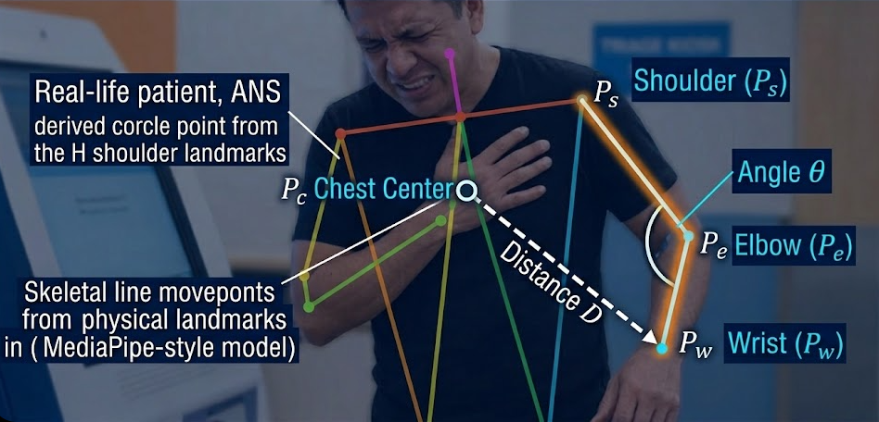
- Required Consecutive Frames (F) = $Fps x t=60$ frames.
Figure 3-5 Chest Pain Recognition Logic

- Physically Sign Analysis with HSV Color Space
To check how urgent a patient in some case, must have to look at their facial skin color. This project focus on Pallor or Flushing skin face. Then system must uses the following steps:
Region of Interest (ROI) Extraction
- To filter noise from non-skin features such as, eyes or lips. System will use facial landmarks to isolate the calculated area space. That centroid of the ROI is calculated based on three reference points is the eye, nose and ear
$Cheek_{X}=\frac{Eye_{x}+Nose_{x}+Ear_{x}}{3} x Imagewidth$ (3-6)
$Cheek_{y}=\frac{Eye_{y}+Nose_{y}+Ear_{y}}{3} x Imageheight$ (3-7)

When the center point is defined, the system will generates a bounding box to crop the skin surface for calculating.
Color Space Transform
Input frames from the webcam were BGR (Blue, Green, Red) format. And because of BGR is highly sensitive to with lighting changes. It can be fixing by the system converts the ROI to the HSV value, by:
- Hue (H) is a wavelength or the actual color
- Saturation (S) was the intensity of the color
- Value (V) was the brightness

Baseline Calibration and Configuration
Since everyone has different skin tones. A single threshold doesn't work for every case. Therefore, system will use the first 3 seconds to learn the patient's natural look. It will calculates their average hue and saturation, to create a standard baseline for more accurate tracking
$Baseline_{S}=\frac{1}{n} \sum_{i=1}^{n}{S_{i}}$ (3-8)
$Baseline_{H}=\frac{1}{n} \sum_{i=1}^{n}{H_{i}}$ (3-9)

Classification Logic
Then the system will compares the current frame's values of CurrentS and CurrentH. Against the baseline logic:
- Pallor is a decrease in blood flow, that mean resulting in reduced color saturation. Then the system will trigger an alert if the saturation drop exceeds a threshold
$Baseline_{S}-Current_{S}>Threshold_{pallor}$ (3-10)
- Flushing was define by increased blood flow, that it leading to higher saturation and a shift in Hue toward the red spectrum
$|Baseline_{H}-Current_{H}|>Threshold_{hueShift}$ (3-11)
and
${Current}_{S}>{Baseline}_{S}+Threshold_{Flush}$ (3-12)

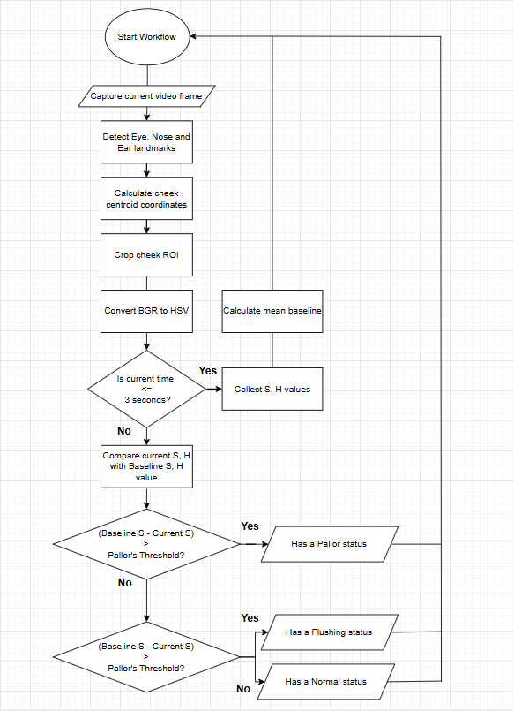
Figure 3-6 Flowchart of Skin Color Analysis using HSV

Project Plan

Table 3-1 Project I Plan

TASK | 2026
TASK | January |  |  |  | February |  |  |  | March |  |  |  | April |  |  |  | May
TASK | 1 | 2 | 3 | 4 | 1 | 2 | 3 | 4 | 1 | 2 | 3 | 4 | 1 | 2 | 3 | 4 | 1 | 2 | 3 | 4
Research topics and Theory
Preparing the Data
Component System testing
Evaluating the System
Testing Prediction of ESI
Develop and Deploy in Website
Document and Report

Table 3-2 Project II Plan

TASK | 2026
TASK | August |  |  |  | September |  |  |  | October |  |  |  | November |  |  |  | December
TASK | 1 | 2 | 3 | 4 | 1 | 2 | 3 | 4 | 1 | 2 | 3 | 4 | 1 | 2 | 3 | 4 | 1 | 2 | 3 | 4
Improve: prediction with CNN and parallel pipeline concept
Do the report
Develop and Deploy in Nurse Dashboard
Merge System with Nurse Dashboard
Evaluate and Testing in real scenario
Extensive Testing & Dataset Updates
Prepare presentation

Chapter 4 Results and Conclusion

In this chapter will present the results of the Project system analysis, including Vision analysis patient performance, LLM system for ESI classification, and the conclusion with future work.

System Performance and Experimental Setup
The architecture relies on real-time analyzing that rather than static weights, the experimental setup and parameters are important to ensuring result accuracy:

Hardware Environment
To comply with the Personal Data Protection Act (PDPA), the system operates using Local Processing with the following specifications:
- Graphics Processing Unit with 8GB VRAM
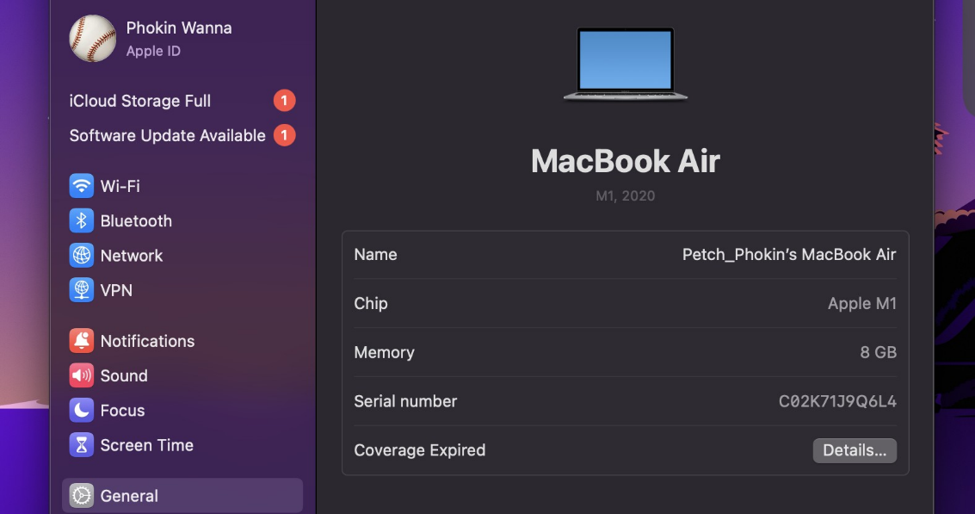
- 1080p resolution webcam and Microphone, on device
Figure 4-1 Hardware Specifications and Requirements

Physical Environment Setup
To create the conditions of a triage nursing kiosk. The following control variables were providing:
- The patient stands at 1.0 - 1.5 meters from the camera and device up from floor at least 1.0 meter.
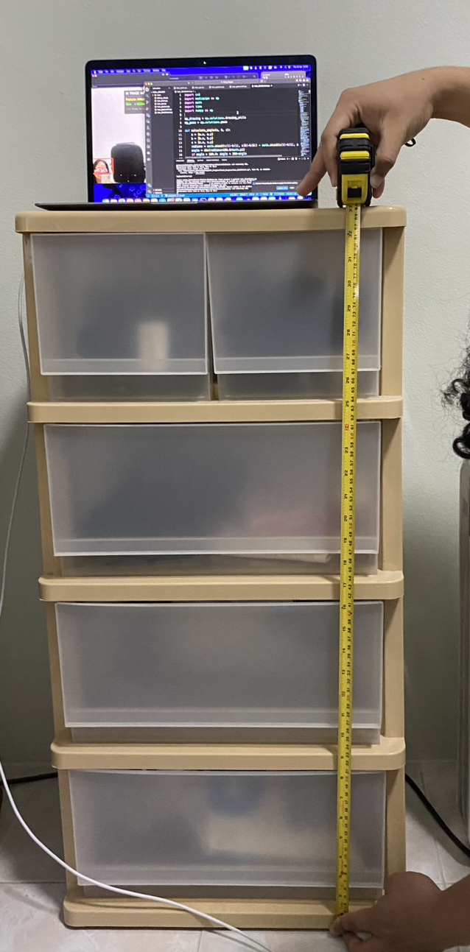
- Background noise must be closing environment to get the efficiency of the Speech to Text system.
Figure 4-2 Distance from equipment to ground
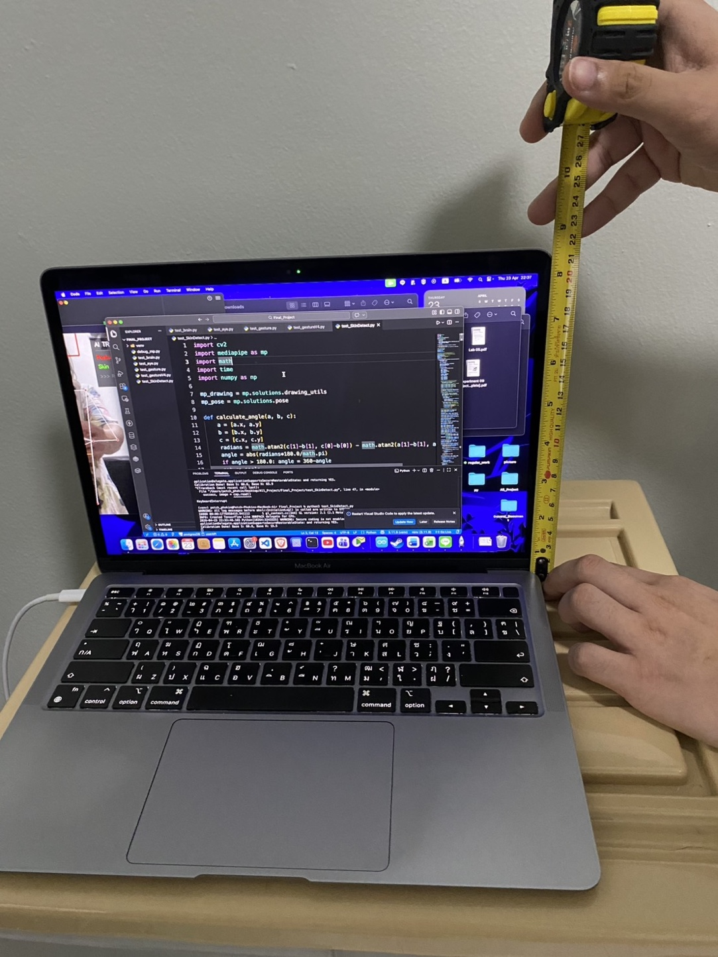
Figure 4-3 Distance from equipment camera to base

Testing Methodology
- System Calibration First 3 seconds of each session are used to make personalized baselines for skin tone and body proportions.
- A total dataset simulated scenarios were tested, divided into target pain gestures and distracting poses to measure error handling performance.

Vision Classification Results
This section evaluates the Vision Module, the system primary contactless for extracting physical data.

Gesture Detection and Dynamic Boundary Results
Based on the experiments. The main three target area such as Head, Chest and Abdomen provide high efficiency
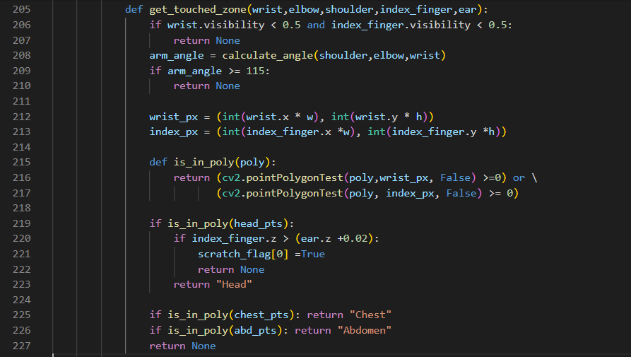
- The system uses the ‘CV’ function to determine whether the coordinates of the wrist or index.
Figure 4-4 Gesture detection’s logic
If contact is up to 2.0 seconds it will change from the 'Analyzing' to 'Anomaly Detected'. Prevents false detection caused by regular body movements.

- Setting the Chest Ratio to ‘0.55’ of the upper body length. It allows system to clearly define between chest pain and abdominal pain. Even when the patient turns sideways or bends over.

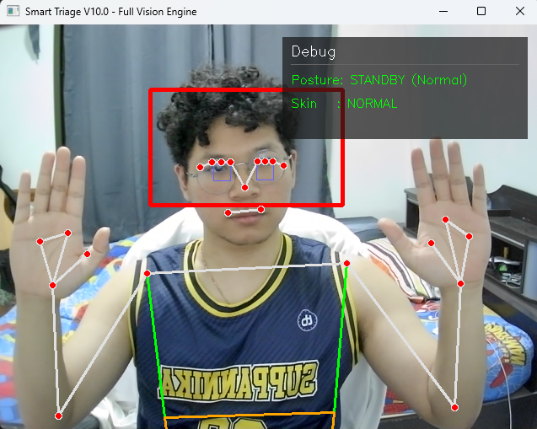
Figure 4-5 Testing Vision System: Normal posture

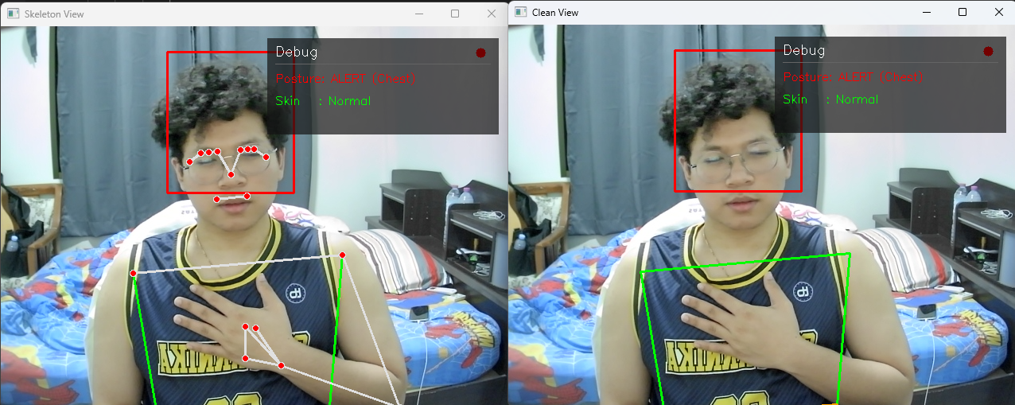
Figure 4-6 Testing Vision System: Chest pain posture

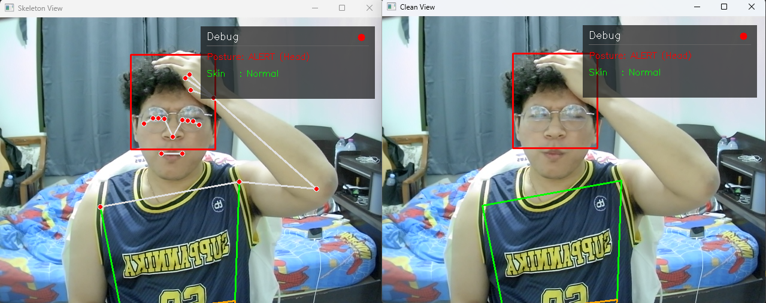
Figure 4-7 Testing Vision System: Head pain posture

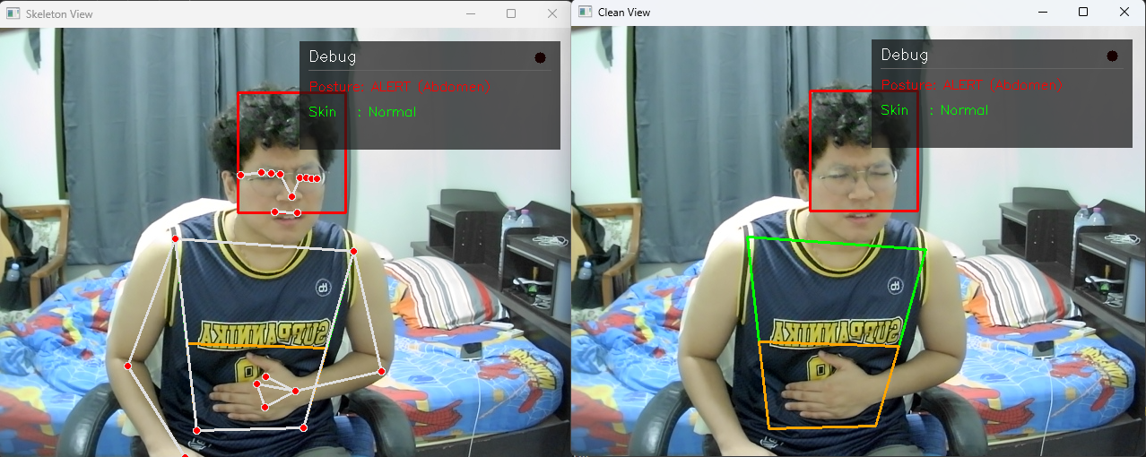
Figure 4-8 Testing Vision System: Abdomen pain posture

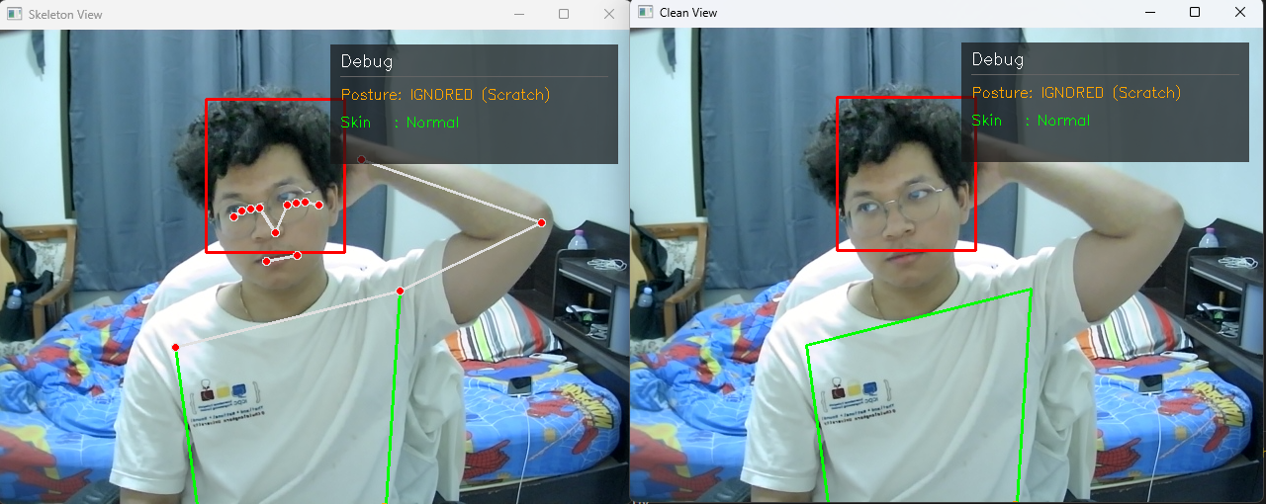
Figure 4-9 Testing Vision System: Unnecessary posture - Scratching
- Analyzes Z axis depth to locate the hand relative to the head. If the hand is deeper than the ear alignment, it classified as scratching rather than a headache symptom.

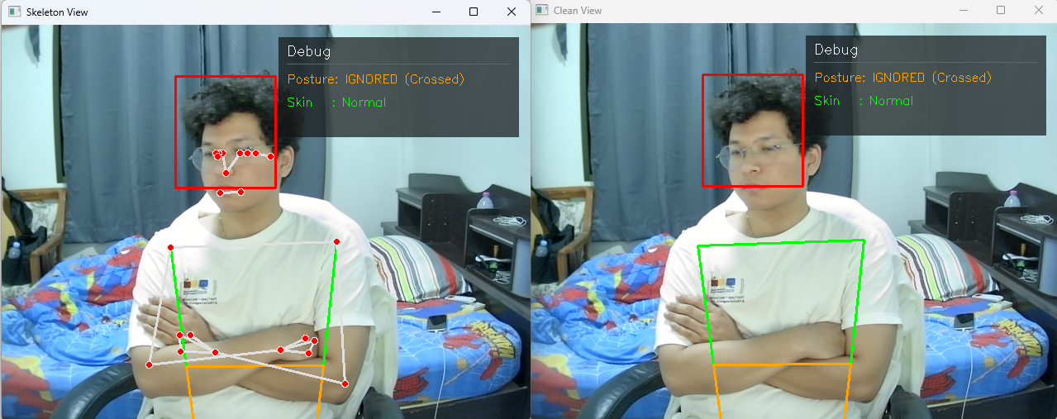
Figure 4-10 Testing Vision System: Unnecessary posture – Crossed Arms
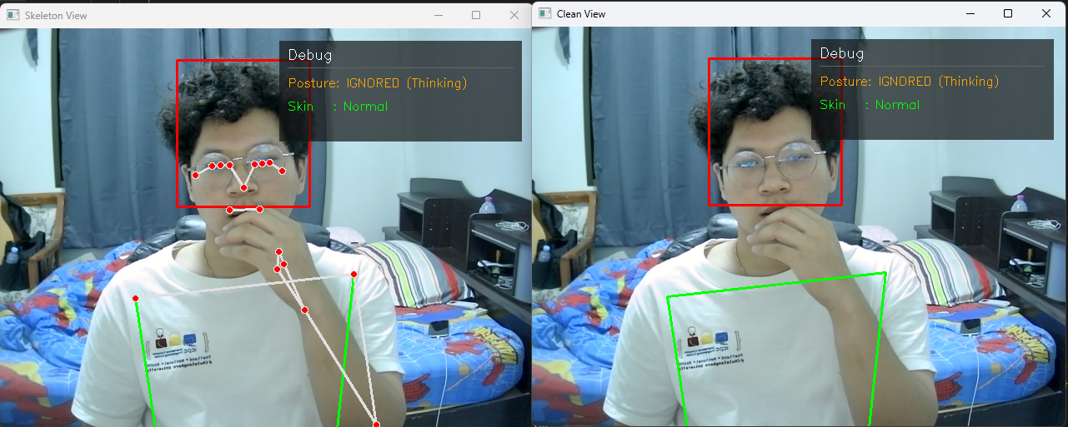
- System detects a Line Segment Intersection between the arms. And triggers if an intersection exists and the elbow angle is 60 - 115°.
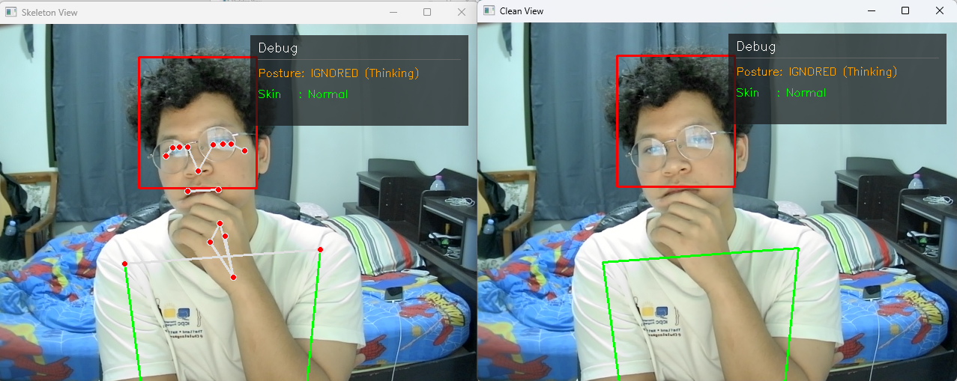
Figure 4-12 Testing Vision System: Unnecessary posture – Thinking (1)
Figure 4-12 Testing Vision System: Unnecessary posture – Thinking (2)
- Calculates the wrist to mouth distance. If it is within 30% of the shoulder width, the action is classified as a normal posture and the alert is suppressed.
Based on the results above. The system can disguise between normal postures and specific gestures. These specific gestures are separate into two groups. Those that affect the system (such as holding the head or stomach from pain) and those that do not (such as scratching the head, which the system might mistake for a headache if not filtered out).
And the results show that the system achieved an accuracy of 72% (from a dataset of 60 tests). Which is in acceptable level. However, more gestures must be added in the future to cover all possible movements and further improve the system's overall accuracy.

Skin Color Analysis
Primary focusing on detect pale skin and Flushing or red skin. This system suitable for face skin change detected, before and while the patient using this system.
- System extracts the ROI by using image segmentation and transforms it from BGR to HSV.
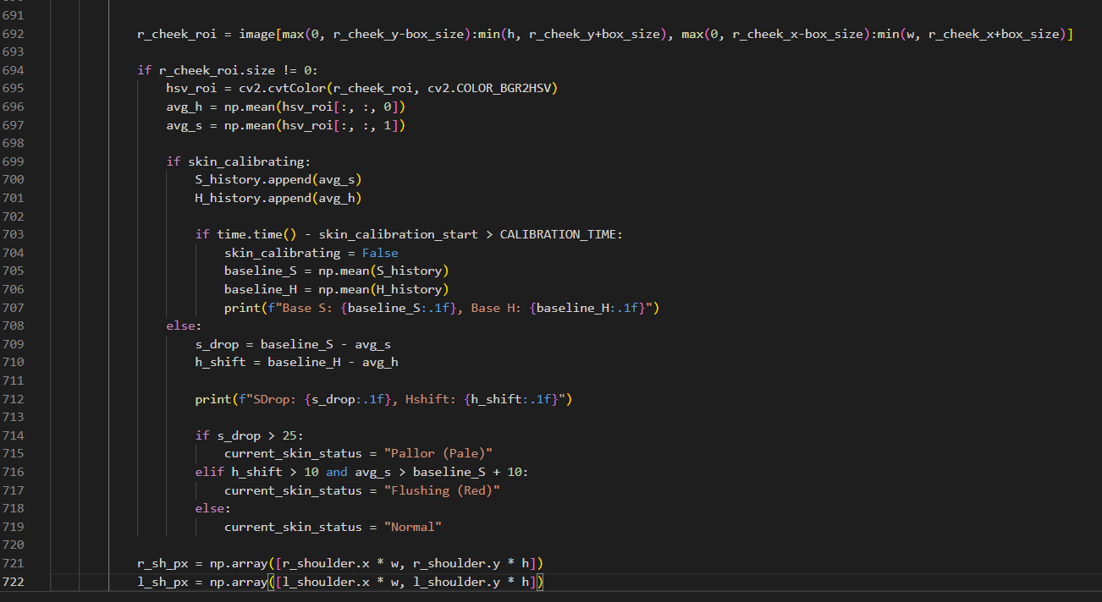
Figure 4-13 Image segmentation and HSV Calculated

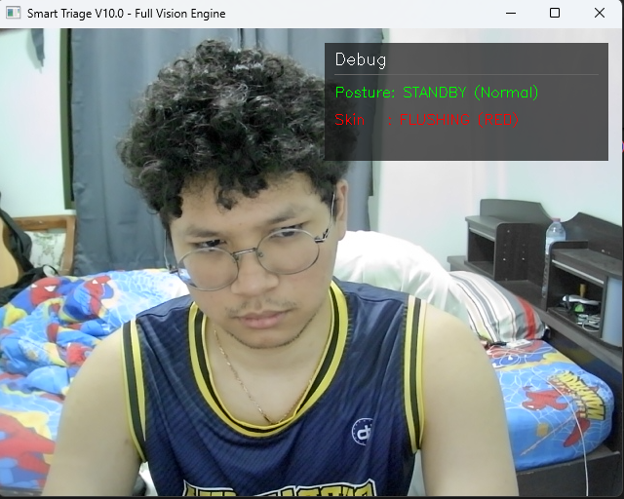
- When simulating a pallor condition. The system accurately detects a drop in saturation and shifted hue value, that will trigger a "Pallor" or “Red Face” flag.

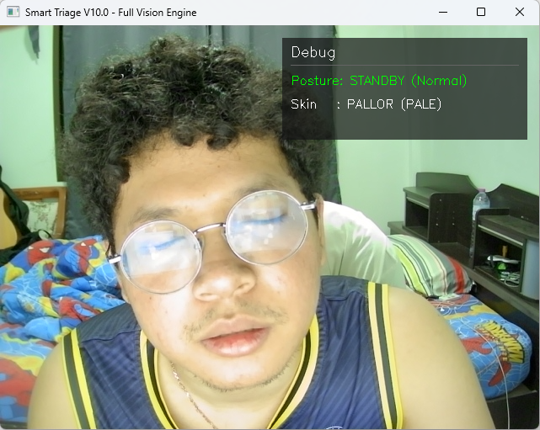
Figure 4-14 Testing Vision System: Red face detected
Figure 4-15 Testing Vision System: Pale face detected
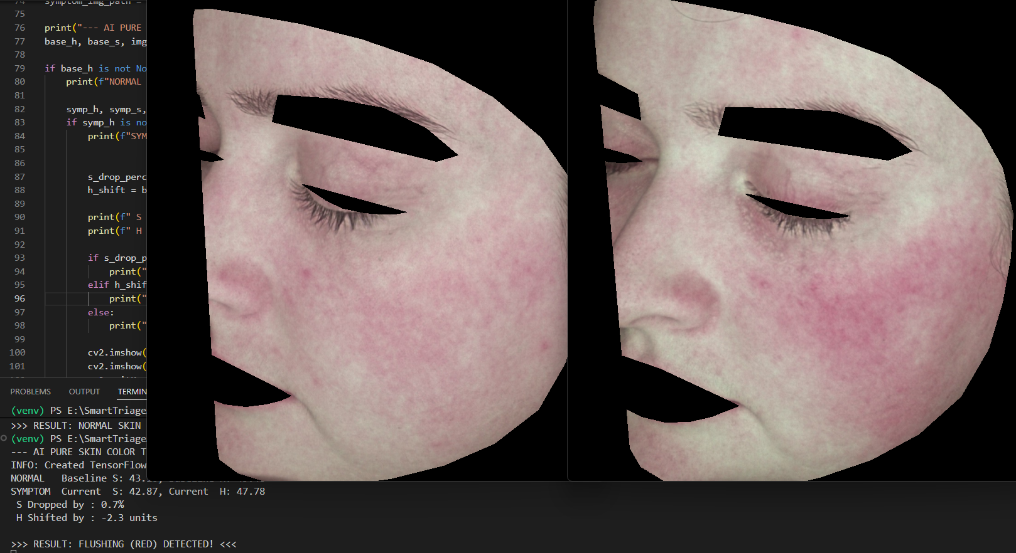
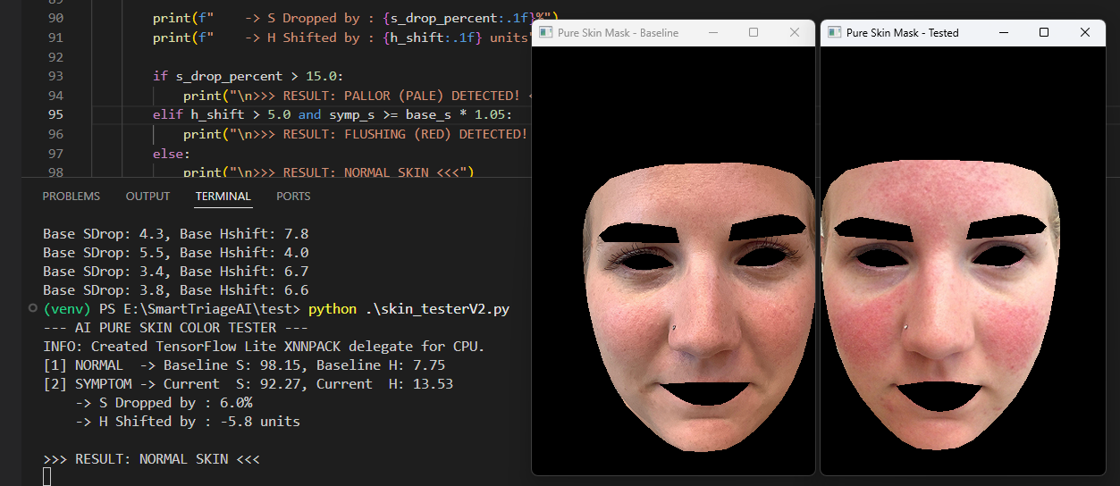
Figure 4-16 Testing skin analysis algorithm with HSV (1)
Figure 4-17 Testing skin analysis algorithm with HSV (2)

Based on the images shown above. The system ability to detect face skin color is generally satisfactory but still has errors. The system currently predicts the correct results about 56% (based on a dataset of 70 tests).
The main reason for this result is likely the color model being used (HSV). It cannot separate the light value from the actual color shades
during calculation.
As a result, the system's color calculations can become distorted because they are easily interrupted with by external lighting (as Figure 4 -15. Light reflex user face that it from monitor. But user do not really have a pale skin. So, that make it provide that result).

LLM Model ESI Classification Results
This section was evaluating the Reasoning Module. By combine Visual Flags from the Vision Module and Audio Transcripts from the Speech to Text module and LLM will classifies patient urgency based on ESI standards.
To provide the results, Conducted Scenario Testing across three cases (critical to non urgent) must generating outputs in JSON format.

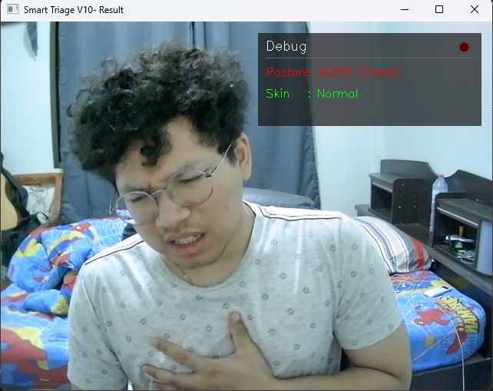
Scenario 1: Critical Emergency (ESI Level 1 - 2)
Figure 4-18 Testing overall System: Critical emergency (scenario 1)
- A patient arrives with exhibiting severe respiratory distress.
- Chest Pain Hold with Any kind of Skin
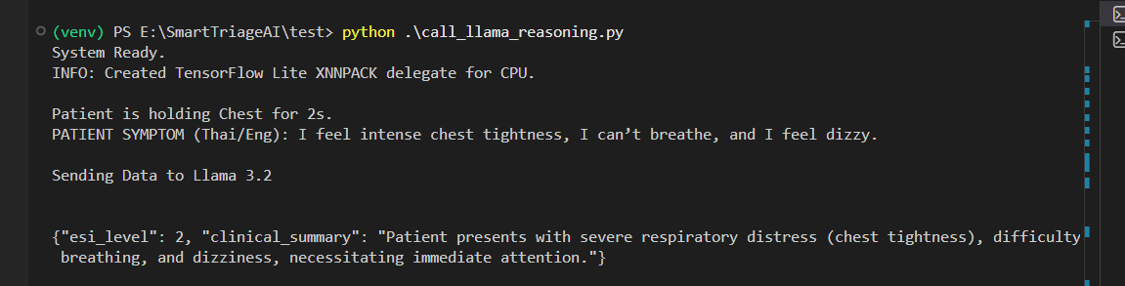
- Context: "I feel intense chest tightness, I can’t breathe, and I feel dizzy."
Figure 4-19 Log of scenario 1’s result
System successfully detects verbal symptoms with Chest Hold signs. It correctly provides ESI Level 2. And system following the rule as specified in the System Prompt to remain within medical safety guidelines.
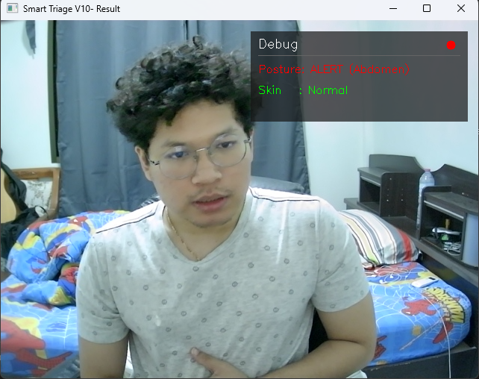
Scenario 2: Urgent Condition Requiring Resources (ESI Level 3)
Figure 4-20 Testing overall System: Urgent Condition (scenario 2)
- A patient presents with persistent abdominal pain.
- Abdominal Pain Hold with Normal Skin
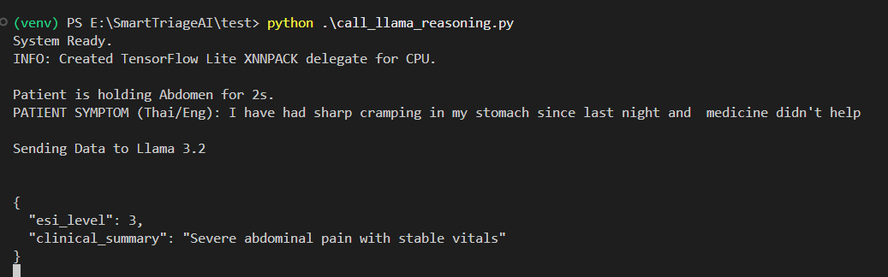
- Context: " I've had sharp cramping in my stomach since last night and medicine didn't help."
Figure 4-20 Log of scenario 2’s result
Although the reported, the Vision Module detected no signs of shock or pallor. The LLM evaluated the patient as stable, That leading to a classification of ESI Level 3.
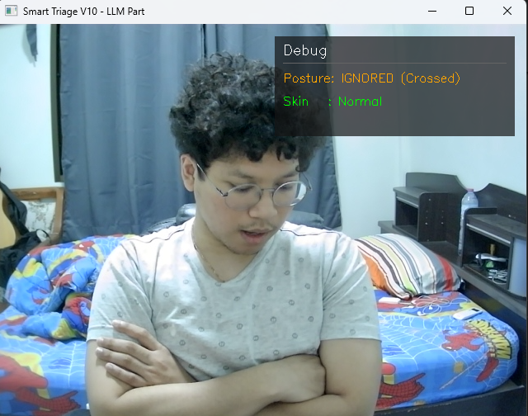
Scenario 3: Non-Urgent (ESI Level 5)
Figure 4-21 Testing overall System: Non-Urgent (scenario 3)
- A patient reports minor symptoms and a non pain related gesture.
- Crossed Arms Hold (Ignored) with Normal Skin
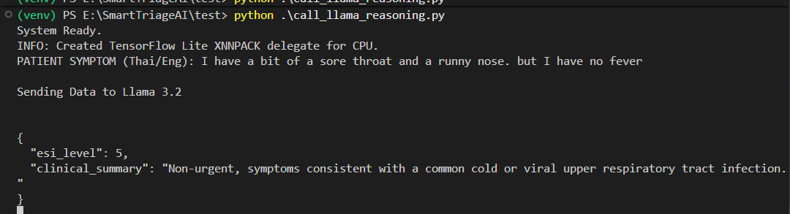
- Context: " I have a bit of a sore throat and a runny nose, but I have no fever."
Figure 4-22 Log of scenario 3’s result
System can detect the ‘Ignored’ status from the Vision Module, the LLM correctly provide the lack of acute physical distress (No emergency) and assigned Level 5, that is mean no evidence needed.
Testing shows that Llama model 3.2 is highly effective at identifying the relation between visual and audio contexts. And found that primary challenge in this module is Inference Latency.

Latency and Computational Performance

Latency Identification
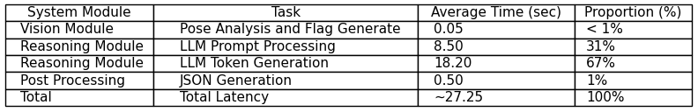
It showed a total delay of 20.4 to 31.8 seconds from receiving input to showing the result. That is mean it must analyze each part of the process to find exactly problems.
Table 4-1 Breakdown System Latency
- Table shows that the ‘Reasoning Module’ is the main cause of the delay. Taking 98% of the processing time. Running the model at full quality used too much VRAM

Optimization Methodologies
- The model weights were changed from Float16-bit to 4-bit Quantization using the Ollama framework. Change the model size from 6GB to 2GB. This change made the system much faster at generating text.
- System parameter was changed from long sentences to a key value format. It reduced the time the LLM spends reading.

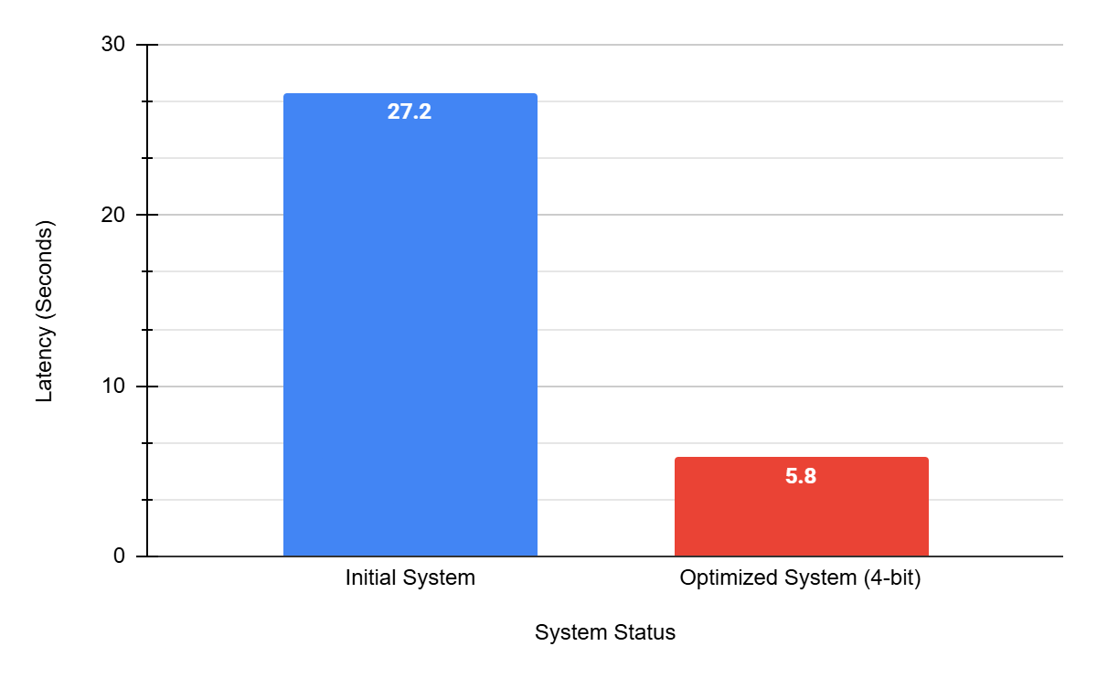
Post-Optimization Performance Results
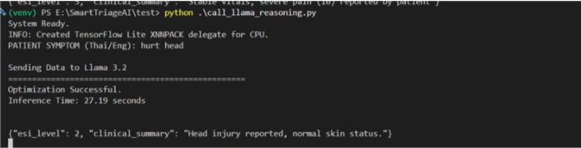
Figure 4-23 Latency Comparison of 16-bit and 4-bit Model
Figure 4-24 Log Optimized Execution Time (16-bit Model)

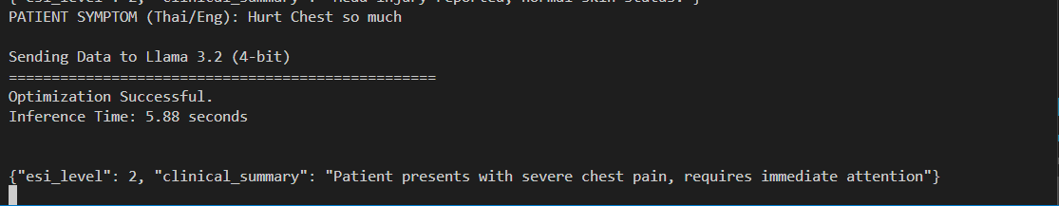
Figure 4-24 Log Optimized Execution Time (4-bit Model)

Results:
- Prefill time reduced from 8.45 seconds to 1.2 seconds.
- Generation time reduced from 18.2 seconds to 4.5 seconds.
- Total latency dropped from an average of 27 seconds to 5 – 7 seconds per case.

Conclusion
The ESI Triage System integrates Multidata by combining necessary pain gestures and skin color analysis using hue, saturation, and value from the Vision Module with patient symptom descriptions.
It shows that adding physical context to the patient's history, helps the system accurately classify urgency and generate a Clinical Summary in JSON format according to medical standards. And after optimization, the processing time is fast enough to meet the actual needs of a hospital triage point in normal environment work filed. However, this project still needs some point to improved more such as accuracy (skin analysis, pain gestures and even triage accuracy) by using ML to train the data for more accuracy. And system must still work on dynamic environment.

Future Work
- Using CIELAB instead of HSV (to improve skin analysis accuracy)
- Deploy web application dashboard
- Integrate data from physical medical devices
- Implement another ML model to train the system algorithms

References

- AWS (Amazon Web Services). "What is a Large Language Model (LLM)?"[Online].Available:https://aws.amazon.com/what-is/large-language-model/ [Accessed: Feb. 27, 2026].
- Vaswani, A., Shazeer, N., Parmar, N., Uszkoreit, J., Jones, L., Gomez, A. N., Kaiser, Ł., & Polosukhin, I. (2017). "Attention is all you need." Advances in Neural Information Processing Systems (NeurIPS 2017), 30, 5998–6008. Available: https://papers.nips.cc/paper/7181-attention-is-all-you-need.
- ResearchGate, Margaret Warton, “Evaluation of the Emergency Severity Index in US Emergency Departments for the Rate of Mistriage” .Available:https://www.researchgate.net/publication/369333241_Evaluation_of_the_Emergency_Severity_Index_in_US_Emergency_Departments_for_the_Rate_of_Mistriage.
- ResearchGate, Ramesh P Aacharya, “Emergency Department Triage: An EthicalAnalysis”.Available:https://www.researchgate.net/publication/51701713_Emergency_Department_Triage_An_Ethical_Analysis.
- Bradski, G. (2000). "The OpenCV Library." Dr. Dobb's Journal of Software Tools, 25(11), 120–125. Available: https://www.proquest.com/trade-journals/opencv-library/docview/202684726/se-2
- LeCun, Y., Bengio, Y., & Hinton, G. (2015). "Deep learning." Nature, 521(7553), 436–444. Available: hhttps://www.cs.toronto.edu/~hinton/absps/NatureDeepReview.pdf
- Abadi, M., Barham, P., Chen, J., Chen, Z., Davis, A., Dean, J., Devin, M., Ghemawat, S., Irving, G., Isard, M., et al. (2016). "TensorFlow: A system for large-scale machine learning." 12th USENIX Symposium on Operating Systems Design and Implementation (OSDI 16), 265–283. Available: https://www.usenix.org/system/files/conference/osdi16/osdi16-abadi.pdf
- Radford, A., et al. (OpenAI). "Robust Speech Recognition via Large-Scale Weak Supervision" (Whisper Paper).Available: https://openai.com/research/whisper
- Silberschatz, A., Galvin, P. B., & Gagne, G. (2018). Operating System Concepts (10th ed.). John Wiley & Sons. Available: https://www.cs.uic.edu/~jbell/CourseNotes/OperatingSystems/4_Threads.html
- J. R. Silva et al., "Designing Effective User Interface Experiences for a Self-Service Kiosk to Reduce Emergency Department Crowding," 2020 IEEE International Conference on Healthcare Informatics (ICHI), 2020. Available: https://ieeexplore.ieee.org/document/9201858/
- M. S. Khan et al., "Contactless Patient Care Using Hospital IoT: CCTV Camera Based Physiological Monitoring in ICU," IEEE Access, vol. 11, pp. 102292-102305, 2023. Available:https://ieeexplore.ieee.org/document/10229220/
- Thirunavukarasu, A. J., et al. (2023). "Large language models in medicine." Nature Medicine. Available: https://www.nature.com/articles/s41591-023-02448-8
- Risfendra."Contactless Infant Height Measurement for Enhanced Early Detection of Stunting Using Computer Vision Techniques". IEEE Access, 2025. Available: https://ieeexplore.ieee.org/document/10910102/
- H R Nishanth. "StrideSync - AI Enhanced Workout Tracking and Form Validation".IEEE, 2024. Available: https://ieeexplore.ieee.org/document/11035904/

